**Operating Systems – Project 1**  
- Simple Scheduling -

ChangYoon Lee, ChanHo Park

Dankook University, Korea Republic

[32183641@gmail.com](mailto:32183641@gmail.com), [chanho.park@dankook.ac.kr](mailto:chanho.park@dankook.ac.kr)

**Abstract.** Most modern operating systems have extended the concept of the process to allow having multiple threads of execution and thus to perform more than one task at a time (*Silberschatz et al., 2014*). While allowing this multi-threaded concept, there are some issues to consider in designing it: Synchronization (Concurrency Control). In this paper, we will discuss the concept of the multi-thread, synchronization examples, and their solutions, especially on producer and consumer problems. Also, we will implement the example case of producer and consumer problems with a multi-threaded word count program and evaluate it.

**Keywords:** Concurrency Control, Multi-Thread, Mutex, Producer and Consumer, Semaphore, Synchronization, Reader and Write

# Introduction

In a single-processor computer system, only one process can run at a single time. Other processes must wait until the CPU resources are free and can be rescheduled. A process is executed until it must wait, typically for the completion of the I/O request. However, in multiprogramming, some process runs at all time, to maximize CPU utilization. Multiprogramming tries to use the waiting time productively. Some process is loaded into the memory at one time, and when one process has to wait, the operating system takes the CPU resources away from the process and gives the CPU resources to another process. The following progress continues, every time one process has to wait, while another process takes over the use of the CPU resources.

Scheduling the following progress is a fundamental operating system function. Almost all the computer resources are scheduled before use. Since the CPU is one of the primary computer resources, CPU scheduling is central to the operating system design.

In this paper, we will first explain the concepts of process, process scheduling, Inter-process communication (IPC), and CPU scheduling. By applying these concepts, we will explain how we implemented the simple scheduling program and its results for different algorithms, such as first-come-first-served (FCFS), shortest job first (SJF), round-robin (RR), and completely fair safe (CFS). Also, we will show the performance of each algorithm based on the features discussed in a later section. At the end of the paper, we will present the result of the execution of the different scheduling algorithms and compare them.

# Requirements

# 

Figure 1 - Requirement Specification

Figure 1 shows the requirements for a simple scheduling program. The implementations for these requirements will be described in detail afterwards.

# Concepts

## Process

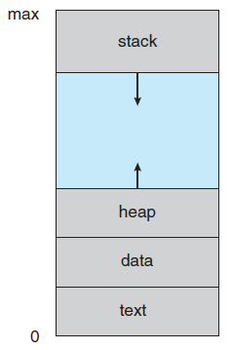

Figure 2 - Layout of the Process in the Memory (Silberschatz et al., 2014)

Modern computers allow multiple programs to be loaded into the memory and executed concurrently. This operation requires firmer control and more compartmentalization of the various programs. To fulfill this requirement, the operating systems need the notion of a process, which is a program in execution. A process is the unit of work in a modern time-sharing system.

The process is an instance of a program in execution. A process is more than the program code, which is known as a text section. It is also consisting of a program counter (PC) and the contents of the registers that present the current state of the process. A process also includes the stack, which contains the temporary data, the data section, which contains global variables, and the heap, which is the memory that is dynamically allocated during the process runtime. The structure of the process is presented in Figure 2.

## Process State

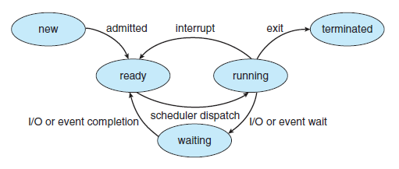

Figure 3 - Diagram of the Process State (Silberschatz et al., 2014)

As a process is in execution, it changes its state. The state of a process can be defined in the part by the current activity of the process. The process may be in one of the following states:

* **New**: The process is being created.
* **Running**: Instructions are being executed.
* **Waiting**:The process is waiting for some event to occur.
* **Ready**: The process is waiting to be assigned to a process.
* **Terminated**: The process has finished the execution.

It is important to realize that only one process can be running on any processor at any instant. However, many processes may be ready and waiting. The state diagram that presents these states is presented in Figure 3.

## Process Control Block

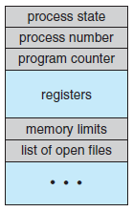

Figure 4 - Process Control Block (PCB) (Silberschatz et al., 2014)

Each process in the operating system is presented in a process control block (PCB), which is also called a task control block. The PCB is presented in Figure 4. It contains much information associated with a specific process, including the following information

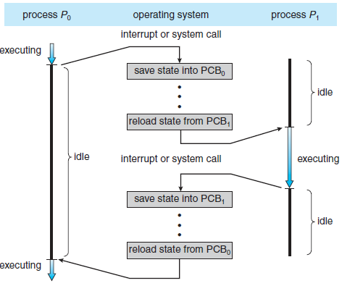

Figure 5 - Diagram of the Context Switching from Process to Processs (Silberschatz et al., 2014)

* **Process state**: The state may be new, ready, running, waiting, or terminated.
* **Program counter**: The program counter indicates the address of the next instruction to be executed for this process.
* **CPU registers**: Depending on the computer architecture, the registers vary in number and type. They include accumulators, index registers, stack pointers, and general-purpose registers. Along with the program counter, the following state information must be saved when an interrupt occurs, to allow the process to be continued correctly afterward. The following progress is presented in Figure 5.
* **CPU scheduling information**: This information includes a process priority, pointers to scheduling queues, and any other scheduling parameters.
* **Memory management information**: This information may include such items as the value of the base and limit registers and the page table, or the segment tables, depending on the memory system used by the operating system.
* **Accounting information**: This information includes the amount of CPU and real-time used, time limits, account numbers, and job or process numbers.
* **I/O status information**: This information includes the list of I/O devices allocated to the process and a list of open files.

In short, the PCB simply used as the repository for any information that may vary from process to process.

## Process Scheduling

In multiprogramming, it has some process running at all times, to maximize CPU utilization. Also, time-sharing switches the CPU among processes so that the users can interact with each program frequently while it is running. To implement the following operations, the process scheduler selects an available process for program execution on the CPU. In the case of the single-processor system, there will never be more than one running process. If there are more processes, the rest of the processes will have to wait until the CPU is free and can be rescheduled.

## Scheduling Queues

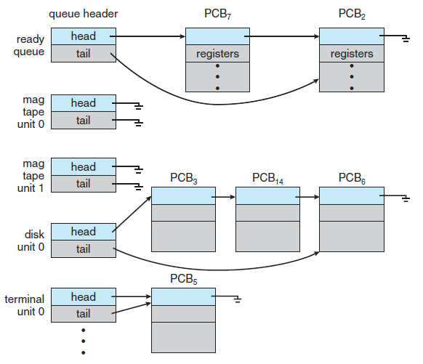

Figure 6 - Multiple Queues in the Operating System (Silberschatz et al., 2014)

As a process enter the system, it is put into the job queue, which consists of all processes in the system. The process that is residing in the main memory and are ready and waiting to execute are kept on a list called the ready queue. The queue is generally stored as a linked list. A ready queue header contains the pointers to the first and final PCBs in the list. Each PCB includes a pointer field that points to the next PCB in the ready queue.

The system also includes the other queues. When a process is allocated the CPU, it executes for a while and eventually quits, is interrupted, or waits for the occurrence of a particular event, such as the completion of an I/O request. Since there are many processes in the system, the disk may be busy with the I/O request of some other process. Therefore, the process may have to wait for the disk. The list of processes waiting for a particular I/O device is called a device queue. The following queue is presented in Figure 6.

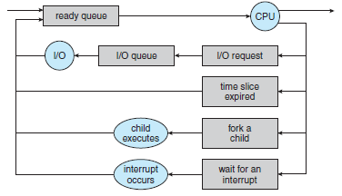

Figure 7 - Queueing-Diagram Representation of Process Scheduling (Silberschatz et al., 2014)

Figure 7 shows the representation of the queuing diagram. Each box in Figure 7 represents a queue. There are two types of queues, which are a ready queue and a set of device queues. The circles represented in Figure 7 are the resources that serve the queues, and the arrow indicates the flow of processes in the system.

A new process is initially put in the ready queue. It waits in the ready queue until it is selected for execution, or dispatched. Once the process is allocated the CPU and is in execution, the following events can occur:

* The process can issue an I/O request and then be placed in an I/O queue.
* The process can create a new child process and wait for the child’s termination.
* The process can be removed forcibly from the CPU, as a result of an interrupt, and be put back in the ready queue.

In the first two cases, the process switches from the waiting state to the ready state and is then put back in the ready queue. A process continues this process until it terminates, at the time it is removed from all queues and has its PCB and resources deallocated.

## Scheduler

A process migrates among the various scheduling queues throughout its lifetime. The operating system must select, for scheduling purposes, processes from these queues in some method. The selection of the process is carried out by the appropriate scheduler. There are two schedulers, which are long-term scheduler (job scheduler), and the short-term scheduler (CPU scheduler),

The long-term scheduler selects the processes to form the process pool and loads them into the memory for execution. The short-term scheduler selects the process that is ready to execute and allocates the CPU to one of them. The primary distinction between these two schedulers is in the frequency of the execution. The short-term scheduler must select a new process for the CPU frequently. However, the long-term scheduler executes with much less frequency, to create a new process. Therefore, it controls the degree of multiprogramming. If the degree of multiprogramming is stable, the average rate of the process creation must be equal to the average departure rate of the processes leaving the system. Also, the long-term scheduler may need to be invoked only when a process leaves the system. Due to the long interval between the executions, the long-term scheduler can afford to take more time to decide which process should be selected for the execution.

In short, the long-term scheduler must make a careful selection. In most cases, most processes can be described as either I/O bound or CPU bound. An I/O bound process spends more of its time doing I/O operation than it spends doing computation. In contrast, a CPU-bound process generates I/O requests infrequently, using more of its time doing computations. The long-term scheduler must select a good process mix of I/O-bound and CPU-bound processes. If all of the processes are I/O bound, the ready queue will be always empty, and the short-term scheduler will have nothing to do. If all of the processes are CPU bound, the I/O waiting queue will almost always be empty, hardware resources are not used, and again the system will be unbalanced. The system with the best performance will have a combination of CPU-bound and I/O-bound processes.

## Inter-Process Communication (IPC)

Processes executing concurrently in the operating system may be either independent processes or cooperating processes. An independent process cannot affect or be affected by the other processes executing in the system. Any process that does not share data with any other process is independent. However, a process is cooperating if it can affect or be affected by the other processes executing in the system, which means that any process that shared data with other processes is a cooperating process.

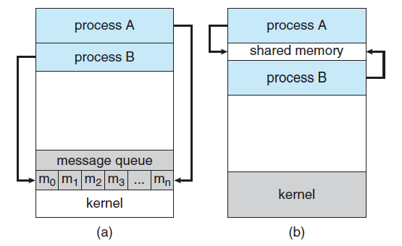

Figure 8 - Communications Models of Shared memory and Message Passing (Silberschatz et al., 2014)

Cooperating processes require an inter-process communication (IPC) operation that will allow them to exchange data and information. There are two fundamental models of inter-process communication, which are shared memory and message passing. In the shared memory model, a region of the memory that is shared by cooperating processes is established. The process can then exchange information by reading and writing data to the shared region. In the message-passing model, communication takes place to be means of messages exchanged between the cooperating processes. The following models are presented in Figure 8.

Both of the models are commonly used in operating systems. Message passing is useful for exchanging smaller amounts of data because no conflicts need to be avoided. Shared memory can be faster than message passing since message-passing systems are typically implemented using system calls and require the more time-consuming task of kernel intervention. In shared memory systems, system calls are required only to establish shared memory regions. Once the shared memory is established, all accesses are treated as routine memory accesses, and no assistance from the kernel is required.

Latest researches indicate that message passing provides better performance than the shared memory on such systems. Shared memory suffers from cache coherency issues, which arise because shared data migrate among several caches. As the number of processing cores on the systems increases, it is possible that message passing is the preferred method for the IPC.

## Message Passing

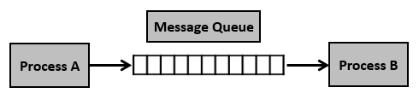

Figure 9 - Message Queue Structure (Silberschatz et al., 2014)

Message passing provides an operation that allows processes to communicate and synchronize their action without sharing the same address space. If processes A and B want to communicate, they must send messages to and receive messages from each other. A communication link must exist between them. This link can be implemented in a variety of ways: direct or indirect communication, synchronous or asynchronous communication, and automatic or explicit buffering.

## Message Queue Naming

Processes that want to communicate must have a way to refer to each other. They can use either direct or indirect communication. Under direct communication, each process that wants to communicate must explicitly name the receiver or sender of the communication. This means that both the sender process and receiver process must name the other to communicate.

A variant of this concept is indirect communication. In this case, only the sender names the receiver, while the receiver does not require the name of the sender. With indirect communication, the messages are sent to and received from the mailboxes, also known as ports. A mailbox can be viewed abstractly as an object into which messages can be placed by the processes and from which messages can be removed. Each mailbox has a unique identification. A process can communicate with another process with several different mailboxes, but two processes can communicate only if they have a shared mailbox.

The process that creates a new mailbox becomes the mailbox’s owner by default. Initially, the owner is the only process that can receive messages through this mailbox. However, the ownership and receiving privilege may be passed to other processes through appropriate system calls. The following provision can result in multiple receivers for each mailbox.

## Message Queue Synchronization

Communication between processes takes place through calls to send and receive primitives. The implementation of these privities can be differed from blocking to nonblocking, which are also known as synchronous and asynchronous. Each primitive can be represented as below:

* **Blocking send**: The sending process is blocked until the message is received by the receiving process or by the mailbox.
* **Nonblocking send**: The sending process sends the message and resumes the operation.
* **Blocking receive**: The receiver blocks until the message is available.
* **Nonblocking receive**: The receiver retrieves either a valid message or not.

## Message Queue Buffering

Generally, the queues can be implemented in three ways:

* **Zero capacity**: The queue has a maximum length of zero, and the link cannot have any messages waiting in it. In the following case, the sender must block the queue until the recipient receives the message.
* **Bounded capacity**: The queue has a finite length n of the queue, and n messages can reside in it. If the queue is not full when a new message is sent, the message is placed in the queue, and the sender can continue execution without waiting. However, the capacity of the link is finite. Therefore, if the link is full, the sender must block it until the space is available in the queue.
* **Unbounded capacity**: The length of the queue is infinite, and any number of messages can wait in the queue. The sender never blocks the queue.

The zero-capacity case is referred to as a message system with no buffering. Other cases are referred to as systems with automatic buffering.

## CPU Scheduling

Whenever the CPU becomes idle, the operating system must select the process in the ready queue to be executed. The selection of the process is carried out by the CPU scheduler. CPU scheduler selects a process from the process in the memory that is ready to execute and allocates the CPU to that process.

We denote that the ready queue is not necessarily a first-in, first-out (FIFO) queue. We can consider the various scheduling algorithms, and the ready queue can be implemented in not only the FIFO queue, but also the priority queue, tree, or simply an unordered linked list. However, all the processes in the ready queue are lined up and waiting for a chance to run on the CPU. The records in the queues are generally the process control block (PCB) of the processes.



Figure 10 - Diagram of the Process State where Scheduler Affects (Silberschatz et al., 2014)

CPU scheduling decisions can take place under the following circumstances, which are presented in Figure 10:

* When a process switches from a running state to a waiting state.
* When a process switches from a running state to a ready state.
* When a process switches from the waiting state to the ready state.
* When the process terminates.

For situations 1 and 4, there is no choice in terms of scheduling. A new process must be selected for execution. However, there is a choice for situations 2 and 3. When scheduling takes place only under 1 and 4, the scheduling is non-preemptive or cooperative. In contrast, it is preemptive.

Under non-preemptive scheduling, once the CPU has been allocated to a process, the process keeps the CPU until it releases it either by terminating or by switching to the waiting state. However, preemptive scheduling can result in race conditions when the data are shared among several processes.

## Scheduling Criteria

Different CPU scheduling algorithms have different properties, and the choice of a particular algorithm may favor one class of processes over another. In choosing which algorithm to use in the situation, we must consider the properties of the various algorithms.

The following criteria are the characteristics of the scheduling algorithms that are used for the comparison to make a substantial difference in which algorithm is judged to be best:

* **CPU utilization**: What we want to do is to keep the CPU as busy as possible. The range that shows how busy the CPU is working is CPU utilization.
* **Throughput**: If the CPU is busy executing thee processes, then the work is being done. Throughput presents the number of completed processes per time unit.
* **Turnaround time**: From the point of view of a particular process, the important criterion is how long it takes to execute the process. The interval from the time of the submission of a process to the time of the completion is the turnaround time. This time stands for the sum of periods spent waiting in the ready queue, executing on the CPU, and doing the I/O operations.
* **Waiting time**: The CPU scheduling algorithm does not affect the amount of time during which a process executes or does an I/O operation. It affects only the amount of time that process spends waiting in the ready queue. Waiting time is the sum of the periods spent waiting in the ready queue.
* **Response time**: In an interactive system, turnaround time may not be the best criterion. Often, a process can produce some output early and can continue computing the new results while the previous results are outputting. Also, another measure is the time from the submission of a request until the first response is produced. The following measurement is the response time, which is the time it takes to start responding.

It is desirable to maximize the CPU utilization and throughput and to minimize the turnaround time, waiting time, and response time. In general, we optimize the average measurement. However, under some circumstances, we prefer to optimize the minimum or maximum values rather than the average.

## Scheduling Algorithms

CPU scheduling deals with the problem of deciding which of the processes in the ready queue is to be allocated CPU core. There are many different CPU scheduling algorithms. In the later sections, we will describe some of them with the implementation. Although most modern CPU architectures have multiple processing cores, we will describe the scheduling algorithms in the context of a single processing core, which means that the system is only capable of running one process at a time.

# Simple Scheduling

## Signal and Handler

A program, which is also known as a process, must deal with unexpected or unpredictable events, such as a floating-point error, an alarm clock rings, a termination request from a user, and so on. In the following situations, the signal is used. Signals are the software interrupts and provide a way to handle asynchronous events. Once a signal is generated by some event, it is delivered to a process, which then takes some action in response to the signal. Upon delivery of a signal, a process can operate in the following ways:

* **Ignore it**: literally, ignore the signal.
* **Catch it**: A programmer can arrange for a particular signal to be processed by a special piece of code called a signal handler.
* **Accept the default**: Have the kernel do whatever is defined as the default action for the signals, such as the signal is ignored, the process is terminated, the process is stopped, and so on.

Figure 11 - POSIX Signals

In the signal header file, which is offered by the POSIX system, the signals presented in Figure 11 are defined as the integer value.

Signals can occur during the process execution, and we can also generate the signal explicitly to another process. Generating the signal explicitly is called signal dispatching.

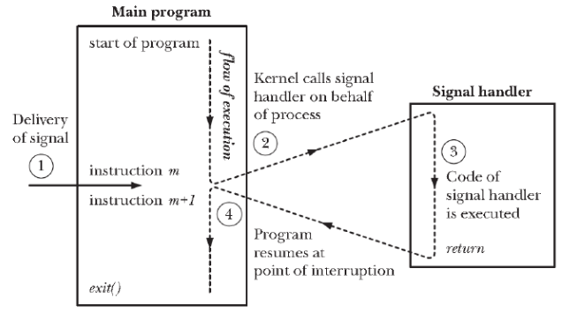

Figure 12 - Signal Delivery and Handler Execution

As the signals are generated asynchronously, we cannot predict the period of the signal generation, which means that the signal can be generated whenever the program is in execution. Figure 12 presents the operation of the signal delivery and the handler execution. According to Figure 12, first, if the signal occurs while the program is executing, it temporarily stops the execution. Next, the signal handler is executed to proceed with the signal. Then, right after the signal proceeds, the next instruction, right after the signal is executed.

Figure 13 – Structure of the SIGACTION System Call

The POSIX system provides the sigaction system call to register the signal handler. The following system call is used to change the action taken by a process on receipt of a specific signal. Figure 13 presents the structure of the sigaction system call.

In this project, we set three main signals, which are the I/O signal, CPU signal, and time clock (tick) signal. In the I/O signal, the program ferrets out each PCB in the waiting queue and decreases the I/O burst time. If the I/O burst time is zero, it pops the PCB from the waiting queue and appends it into the ready queue. In the CPU signal, it selects the next executing process from the ready queue and decreases the CPU burst time. In the time clock (tick) signal, it increases the time tick of the CPU, and prints out the result after executing the I/O and CPU signal.

## Message Passing in System V Messages

System V messages allow the processes to exchange data in the form of messages. Messages can be assigned to a specific type. The server process can direct message traffic between clients to its queue by using the client process PID as the message type. For single message transactions, multiple server processes can work in parallel with transactions that are sent to a shared message queue.

Before a process can send or receive a message, it must initialize the queue through the msgget system call. The owner or creator of the queue can change their ownership or permissions using the msgctl system call. Any process with permission can use the msgctl system call for control operation. Operations to send and receive messages are performed by msgsnd and msgrcv system calls. When a message is sent, its text is copied to the message queue. msgsnd and msgrcv system calls can be performed as either blocking or non-blocking operations. The blocked message operation remains suspended until one of the following three conditions occurs: the call succeeds, the process receives a signal, and the queue is removed.

Figure 14 - msgget System Call Code

msgget system call initializes a new message queue. It can also return the message queue ID to the queue corresponding to the key argument. The values passed as the message flag argument must be an octal integer with a setting for the queue’s permissions and control flags. The following system call is presented in Figure 14.

Figure 15 - msgctl System Call Code

msgctl system call alters the permissions and other characteristics of the message queue. The message queue ID argument must be the ID of an existing message queue. The commands of the msgctl system call are the IPC_STAT (place information about the status of the queue in the data structure pointed to buffer), the IPC_SET (Set the owner’s user and group ID, the permissions, and the size of the message queue), and the IPC_RMID (remove the message queue specified by the message queue ID argument. The following system call is presented in Figure 15.

Figure 16 - msgsnd and msgrcv System Calls Code

msgsnd and msgrcv system calls send and receive messages. The message queue ID argument must be the ID of the existing message queue, The message pointer argument is a pointer to a structure that contains the type of the message and its text. The message size argument specifies the length of the message in bytes. The message flag argument passes the various control flags. The following system call is presented in Figure 16.

## First-Come First-Served Algorithm (FCFS)

The simplest CPU scheduling is the first-come, first-serve (FCFS) scheduling algorithm. In this algorithm, the process that requests the CPU resources first is allocated to the CPU first. The implementation of the FCFS policy is simply managed by a FIFO queue. When a process enters the ready queue, its PCB is linked to the tail of the queue. The running process is then removed from the queue. The code for FCFS scheduling is simple to write and understand.

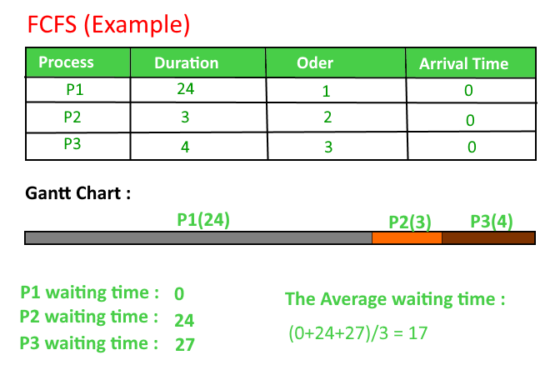

Figure 17 - Example of FCFS Scheduling

Figure 17 shows an example of the FCFS scheduling case. As we can see from Figure 17, even though the FCFS is easy to implement, it has the disadvantage that its average waiting time is often quite long. Also, consider the performance of FCFS scheduling in a dynamic situation. If we have one CPU-bound process and multiple I/O-bound processes. As the process flows around the system, the CPU-bound process will get and hold the CPU. During this time, all other processes will finish their I/O and will move into the ready queue, waiting for the CPU. While the processes wait in the ready queue, the I/O devices are idle. After the CPU-bound process finishes its CPU bursts and moves to an I/O device, all the I/O-bound processes, which have short CPU bursts, execute quickly and move back to the I/O queues. At this point, the CPU sits idle. The following situation is called the convoy effect, which presents the case of all the other processes waiting for the one big process to get off the CPU. This effect results in lower CPU and device utilization than might be possible if the shorter processes were allowed to go first.

## Shortest Job First Algorithm (SJF)

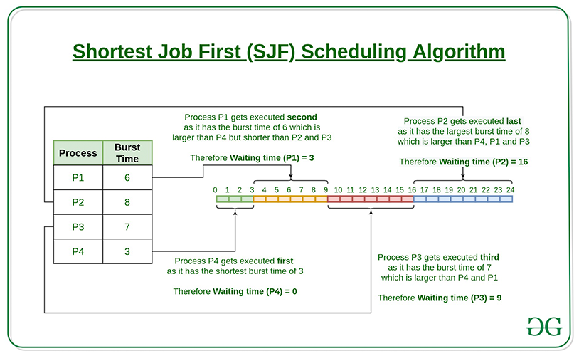

Figure 18 – Example of SJF Scheduling

A different approach to CPU scheduling is the shortest job first scheduling algorithm. This algorithm is associated with each process, the length of the process’s next CPU burst time. When CPU resources are available, it is assigned to the process that has the smallest next CPU burst time. If the next CPU bursts of the two processes are the same, FCFS scheduling is used. Figure 18 presents the execution of the SJF scheduling.

The SJF scheduling algorithm is probably optimal, due to that gives the minimum average waiting time for a given set of processes. Moving a short process before a long one decreases the waiting time of the short process more than it increases the waiting time of the long process. As a result, the average waiting time decreases.

However, the SJF scheduling algorithm cannot be implemented at the level of CPU scheduling, as there is no way to know the length of the next CPU burst. One approach to this problem is to try to approximate SJF scheduling. We may not know the length of the next CPU burst, but we may be able to predict its value. By computing an approximation of the length of the next CPU burst, we can pick the process with the shortest predicted CPU burst.

## Round Robin Algorithm (RR)

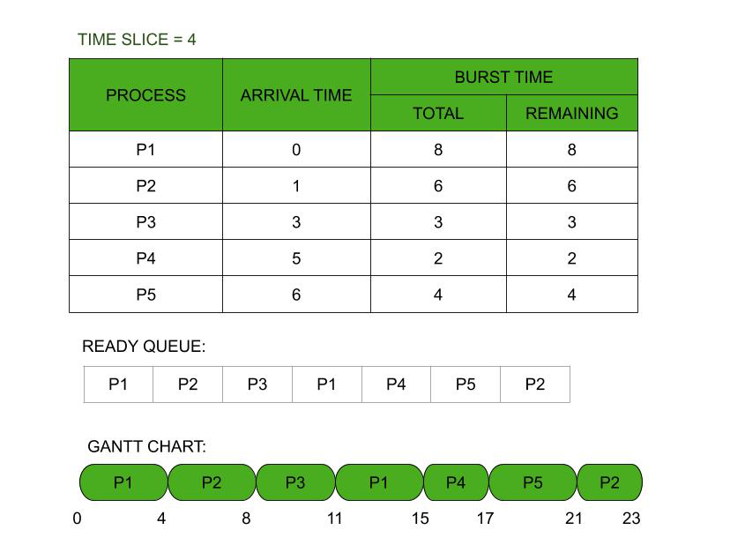

Figure 19 - Example of RR Scheduling

The round-robin scheduling algorithm is like FCFS scheduling, but preemption is added to enable the system to switch between processes. A small unit of time, which is time quantum or time slice, is defined. Generally, time quantum has a range of 10 to 100 milliseconds in length. The ready queue is treated as a circular queue. The CPU scheduler goes around the ready queue, allocating the CPU to each process for a time interval of up to 1-time quantum. To implement RR scheduling, we need to treat the ready queue as a FIFO queue of processes. New processes have been added to the tail of the ready queue. The CPU scheduler picks the first process from the ready queue, sets a timer to interrupt after 1-time quantum, and dispatches the process. Figure 19 shows the execution of the RR scheduling algorithm.

One of two things will happen when we apply the RR scheduling algorithm. The process may have a CPU burst of less than 1-time quantum. In this case, the process itself will release the CPU voluntarily. However, if the CPU burst of the currently running process is longer than the 1-time quantum, the timer will go off and will cause an interruption to the operating system. Then a context switch will be executed, and the process will be put at the tail of the ready queue.

Therefore, we can say that the performance of the RR scheduling algorithm depends heavily on the size of the time quantum. In one extreme case, if the time quantum is extremely large, the RR policy is the same as the FCFS policy. In contrast, if the time quantum is extremely small, the RR policy can result in many context switches.

Also, turnaround time depends on the size of the time quantum. The average turnaround time of a set of processes does not necessarily improve as the time quantum increases. Generally, the average turnaround time can be improved if most processes finish their next CPU burst in a single time quantum. If context switch time is added in, the average turnaround time increases even more for a smaller time quantum, as more context switches are required.

## Program Definition

Before implementing the multi-threaded word count program, we will state the additional program definition that will be used in the real implementation.

* Global Variables

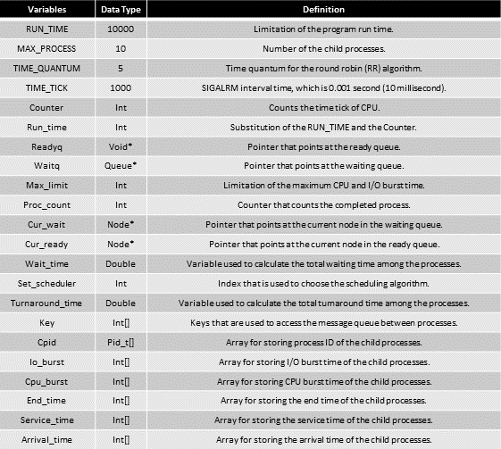

* Modules and Functions

# Implementation

## Queue Header

Figure 20 - Structures used in the Queue

Figure 4 shows the solution code that uses mutex lock to resolve the critical section problem. The acquire function acquires the lock, and the release function releases the lock. A mutex has a Boolean

Figure 21 - Functions used in the Queue

Figure 4 shows the solution code that uses mutex lock to resolve the critical section problem. The acquire function acquires the lock, and the release function releases the lock. A mutex has a Boolean

## Heap Header

Figure 22 - Structure used in the Heap

Figure 4 shows the solution code that uses mutex lock to resolve the critical section problem. The acquire function acquires the lock, and the release function releases the lock. A mutex has a Boolean

Figure 23 - Functions used in the Heap

Figure 4 shows the solution code that uses mutex lock to resolve the critical section problem. The acquire function acquires the lock, and the release function releases the lock. A mutex has a Boolean

## Inter-Process Control (IPC) Message Passing Header

Figure 24 - Structure of the Message Buffer

might be able to use productively. In the aspect of continuously looping for the busy wait, the mutex lock is also called a spinlock because the thread spins while waiting for the lock to become available.

Figure 25 - Message Send Function of the Child Process

might be able to use productively. In the aspect of continuously looping for the busy wait, the mutex lock is also called a spinlock because the thread spins while waiting for the lock to become available.

Figure 26 - Message Receive Function of the Parent Process

might be able to use productively. In the aspect of continuously looping for the busy wait, the mutex lock is also called a spinlock because the thread spins while waiting for the lock to become available.

## Main

Figure 4 shows the solution code that uses mutex lock to resolve the critical section problem. The acquire function acquires the lock, and the release function releases the lock.

Figure 4 shows the solution code that uses mutex lock to resolve the critical section problem. The acquire function acquires the lock, and the release function releases the lock.

Figure 4 shows the solution code that uses mutex lock to resolve the critical section problem. The acquire function acquires the lock, and the release function releases the lock.

Figure 4 shows the solution code that uses mutex lock to resolve the critical section problem. The acquire function acquires the lock, and the release function releases the lock.

Figure 4 shows the solution code that uses mutex lock to resolve the critical section problem. The acquire function acquires the lock, and the release function releases the lock.

Figure 4 shows the solution code that uses mutex lock to resolve the critical section problem. The acquire function acquires the lock, and the release function releases the lock.

# Build Environment

* Build Environment:

1. Linux Environment -> Vi editor, GCC Complier
2. Program is built by using the Makefile.

* Build Command:

1. $make main -> build the execution program for simple scheduler.
2. $make clean -> clean all the object files that consists of the simple scheduler programs.

* Execution Command:

1. ./main 1 {$max_limit}   
   -> Execute the simple scheduler program with the scheduler of FCFS policy with the   
    maximum CPU and I/O burst time of {$max_limit} of the child processes.
2. ./main 2 {$max_limit}   
   -> Execute the simple scheduler program with the scheduler of SJF policy with the   
    maximum CPU and I/O burst time of {$max_limit} of the child processes.
3. ./main 3 {$max_limit}   
   -> Execute the simple scheduler program with the scheduler of RR policy with the   
    maximum CPU and I/O burst time of {$max_limit} of the child processes.

# Results

* Result of the simple scheduler with FCFS policy and 10 maximum burst time:

* Result of the simple scheduler with SJF policy and 10 maximum burst time:

* Result of the simple scheduler with RR policy and 10 maximum burst time:

# Evaluation

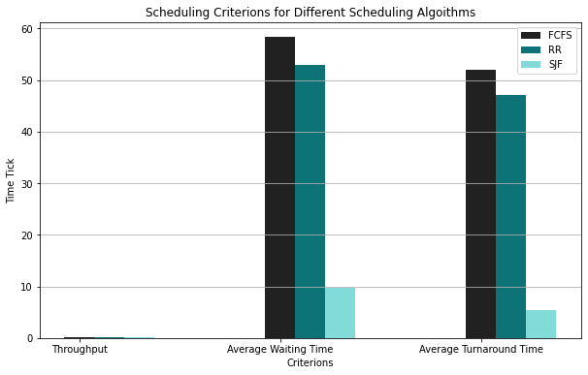

Figures 35 and 36 show the graph result of execution time per number of the threads for the producer and consumer program versions 2.3 that reads the file of FeeBSD9-Orig.tar and the android.tar. The following program is implemented by applying the methods that are presented previously. As we can see from the figures, the execution time decreases as the number of threads increases. In short, the producer and consumer program version 2.3 show the ideal and faster result of execution time among the other programs.

# Conclusion

By understanding this paper, we can understand the basic concepts of thread and multi-threaded programming. Also, we can understand the problems and the solutions that occur by applying the following concept, which is about data dependency and synchronization.

# Citations

[1] Kirvan, P. (2022, May 26). *What is multithreading?* WhatIs.com. Retrieved September 11, 2022, from [https://www.techtarget.com/whatis/definition/multithreading](https://www.techtarget.com/whatis/definition/multithreading%20)

[2] Silberschatz, A., Galvin, P. B., &amp; Gagne, G. (2014). 2.2.1 Command Interpreters. In Operating Systems Concepts. essay, Wiley.

[3] Yan, D. (2020, December 22). *Producer-consumer problem using mutex in C++*. Medium. Retrieved September 9, 2022, from [https://levelup.gitconnected.com/producer-consumer-problem-using-mutex-in-c-764865c47483](https://levelup.gitconnected.com/producer-consumer-problem-using-mutex-in-c-764865c47483%20)

[4] Yoo, S. H. (n.d.). Mobile-os-DKU-cis-MSE. GitHub. Retrieved September 8, 2022, from <https://github.com/mobile-os-dku-cis-mse/>